Diagramming the Premises of Categorical Syllogisms

Diagramming Premises that are Universal Categorical Propositions

Rule about not diagramming the conclusion on the 3 circle Venn diagram

______________________________________________________________
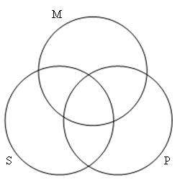
Sample Problem

No stones are minerals.
All pebbles are minerals.
No stones are pebbles.

Diagramming Premises that are Particular Categorical Propositions

Rule about diagramming universal before particular categorical propositions

______________________________________________________________
Sample Problem

No stones are minerals.
Some pebbles are minerals.
No stones are pebbles.

