Basics of Categorical Syllogisms and Basic Diagrams

Categorical Syllogisms

number of premises __________

number of classes mentioned ____________

how many time each class is mentioned ____________

Terms of a categorical syllogism

major term ______________________________________________

minor term ______________________________________________

middle term ______________________________________________

Premises of a categorical syllogism

major premise ______________________________________________

minor premise ______________________________________________
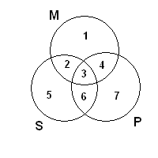
Basic diagram

Area 1 represents objects that are _______________________________

Area 5 represents objects that are _______________________________

Area 7 represents objects that are _______________________________

Area 2 represents objects that are _______________________________

Area 4 represents objects that are _______________________________

Area 6 represents objects that are _______________________________

Area 3 represents objects that are _______________________________

